Pulsar Otago – Getting Started

Contents

Pulsar Otago 1

Local Installation 2

1. Install R onto your computer (if not already installed) 2

2. Install RStudio onto your computer (if not already installed) 2

3. Download the project folder onto your computer 3

4. Open the Project 3

5. Run the Tool 4

### Pulsar Otago

Pulsar Otago is implemented as an R Shiny project. That is, the computational code is written in R, with a separate Windows-style user interface that runs in a web browser remotely, or on your local machine. Using the tool requires no coding.

An online version of Pulsar Otago is available at <https://pulsar.otago.ac.nz>. Alternatively, you can download the Pulsar Otago source code and R Shiny interface files at <https://github.com/phadenz/PulsarOtago> , and run the tool locally. Some tool features (e.g. batch processing) are only available when running locally. See the **Local Installation** section below for detailed instructions.

A typical Pulsar Otago screen shot is shown below. This image shows one of six animals from an input file containing simulated data.

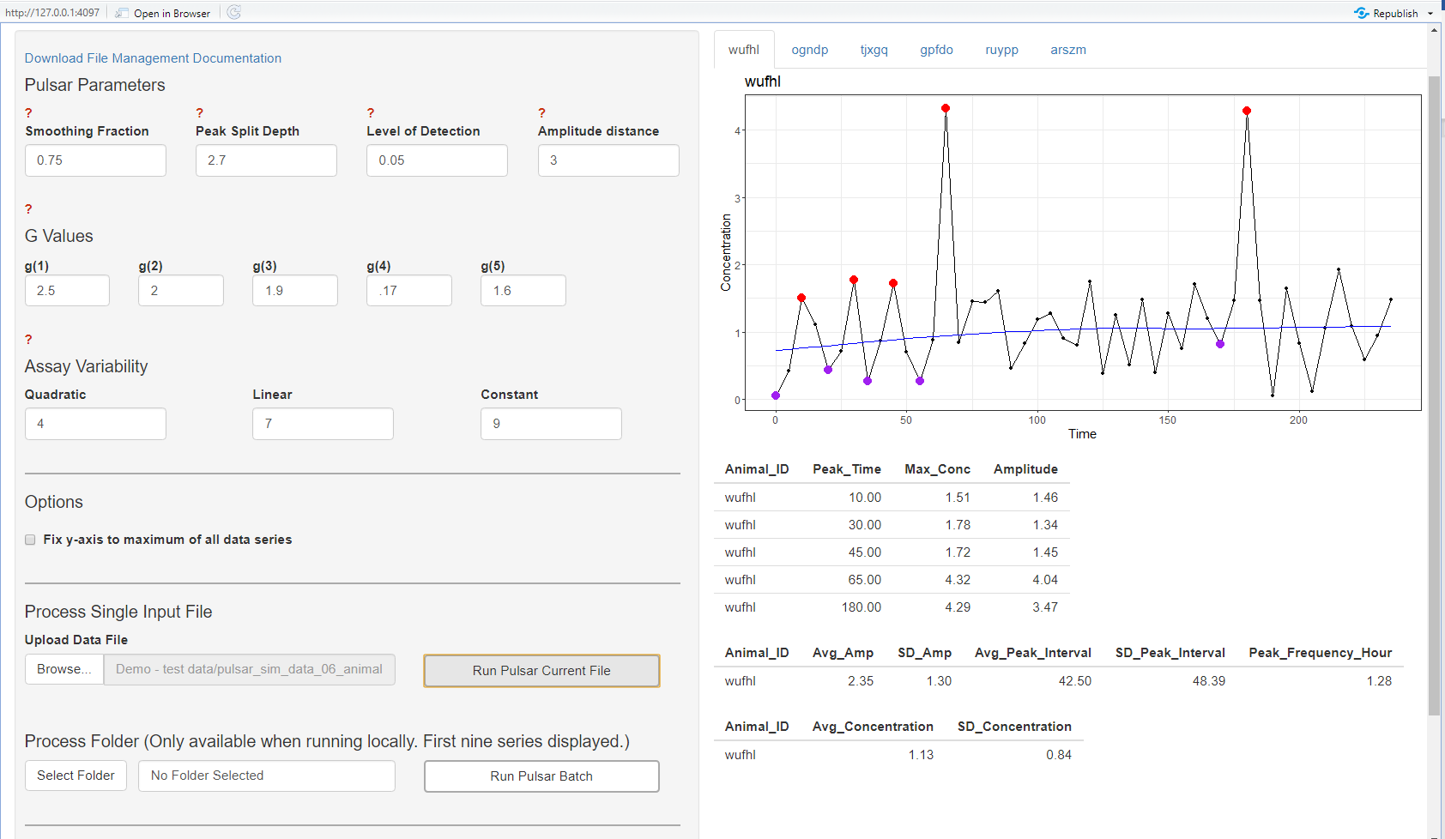

**Pulsar Otago, running locally on simulated data file with six animals**

Algorithm parameters are adjusted using the controls on the left of the screen. Analyse your data by clicking Run Pulsar Current File, or Run Pulsar Batch, as appropriate. Different animal results are displayed by navigating between multiple tabs, which are labelled with each animal’s ID. Points identified as being in pulses are printed in red. Ambiguous pulses at the start or end of the series are printed in green. The nadir points against which amplitude is computed are printed in purple. Output files are saved to the R project folder when running locally, or via an ordinary file download dialogue when using the remote version.

### Local Installation

Pulsar Otago is written in the programming language R and runs in an application called RStudio. No programming is required to use the tool locally, but you will need to install R and RStudio. Both R and RStudio are free, safe, and easy to install.

The complete workflow is (detailed instructions for each step are given below):

1. Install R onto your computer (if not already installed)
2. Install RStudio onto your computer (if not already installed)
3. Download the project folder onto your computer
4. Open the project (only mouse-clicks required)
5. Run the tool (only mouse-clicks required)

### Install R onto your computer (if not already installed)

In your web browser, go to <https://cran.r-project.org/bin/windows/base/> (for Windows machines) or <https://cran.r-project.org/bin/macosx/> (for Mac OS machines). Click the download links as indicated in the images below:

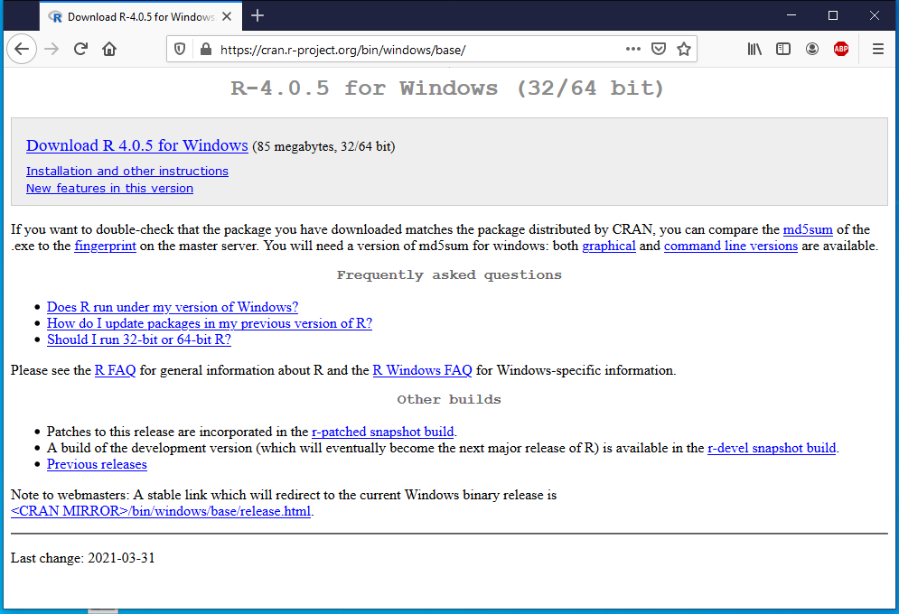 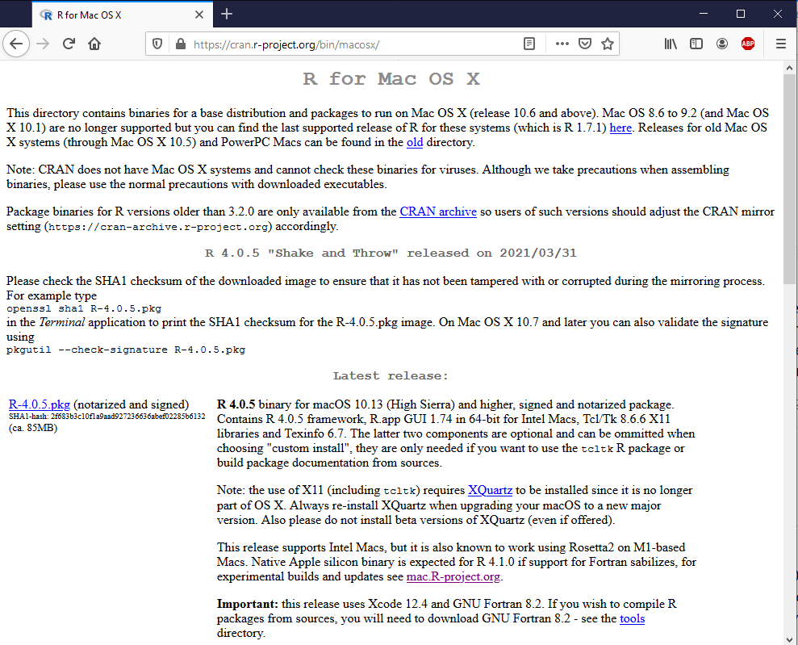

**Windows Mac OS**

In both cases, this will download a single installer file. When download completes, double-click on the downloaded file to install R.

### Install RStudio onto your computer (if not already installed)

In your browser, go to <https://www.rstudio.com/products/rstudio/download/> and click the Download button for the Free version.

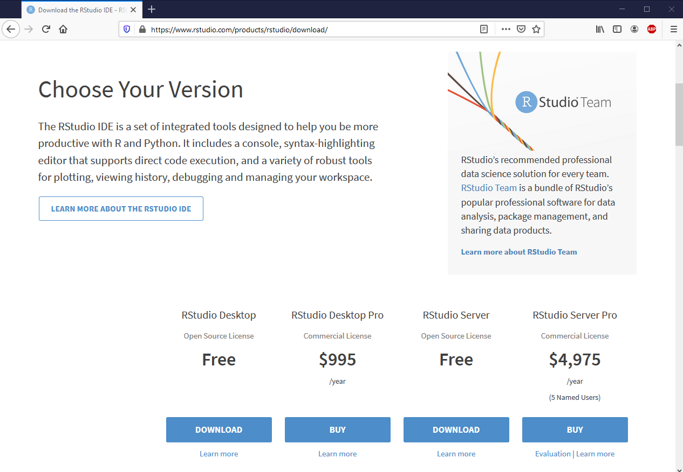

The website will automatically select the correct download for your operating system (Win/Mac). Click the download button:

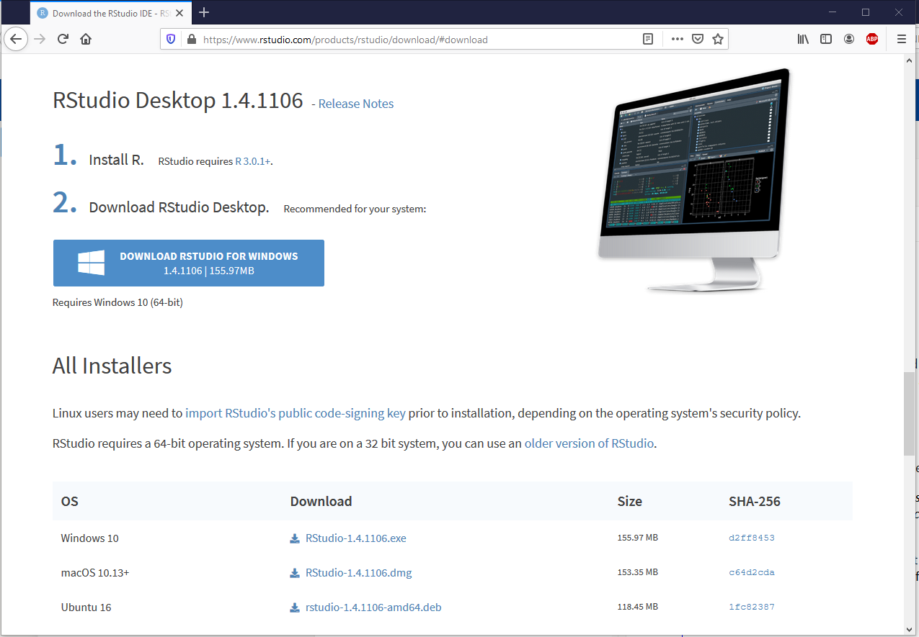 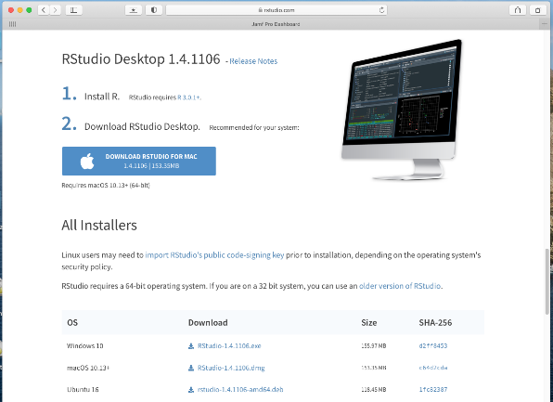

**Windows Mac OS**

Again, each of these downloads a single installer file. When the download completes, double-click on the file to install RStudio.

### Download the project folder onto your computer

The Pulsar Otago source code is available in a git repo at <https://github.com/phadenz/PulsarOtago>. Download the whole repo by clicking the green “Code” button and selecting Download ZIP, as indicated:

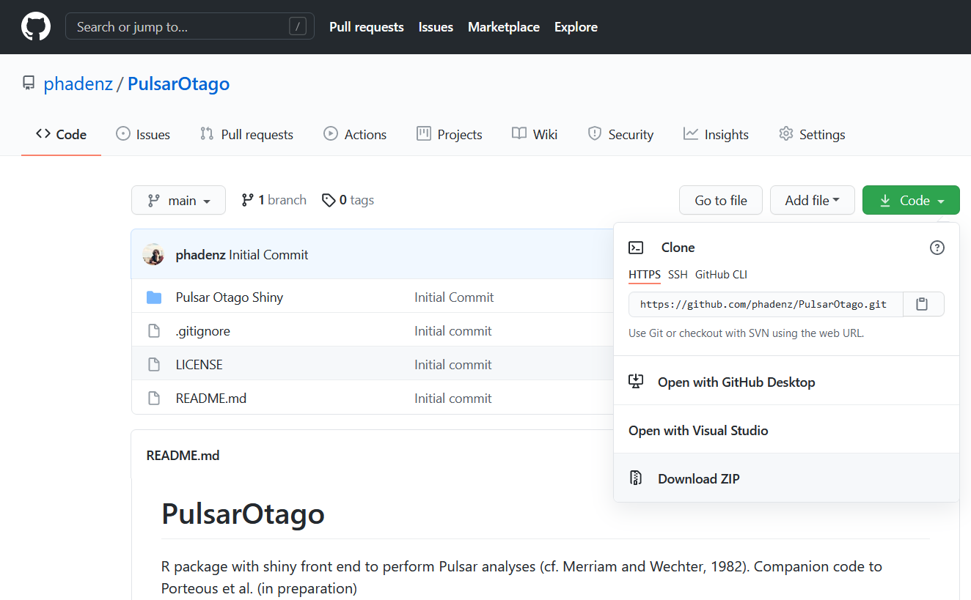

**Downloading the Pulsar Otago source code from github**

This repo contains the project folder **Pulsar Otago Shiny**, and tool documentation.

### Open the Project

Unzip the downloaded repo and open the project folder, **Pulsar Otago Shiny**. The inner folder **pulsaR** is the formal R package containing the computational code files. Files **app.R** and **pulsar_shiny.RProj** are utility files that allow you to run Pulsar Otago interactively from RStudio. Double-click on **pulsaR_shiny.Rproj**

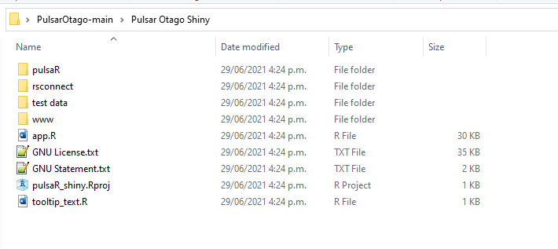

**Pulsar Otago Shiny Project Folder**

The project will launch in RStudio. It will look something like this:

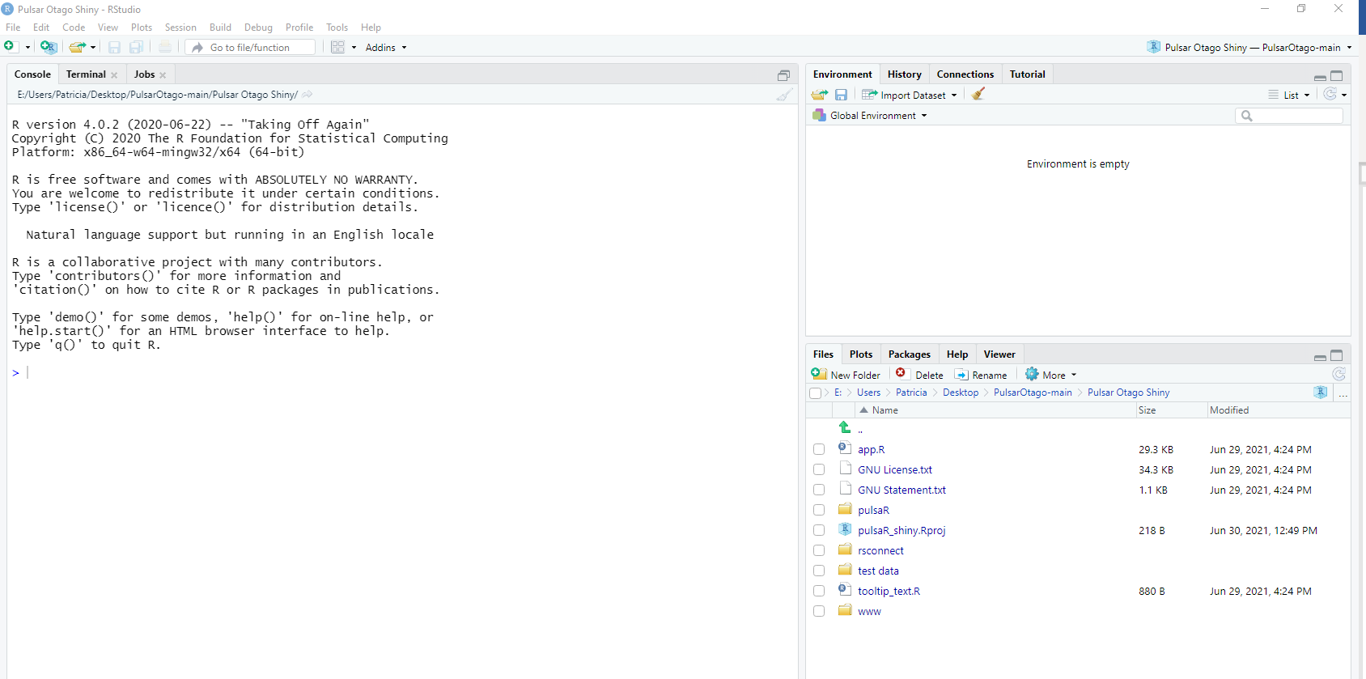

**Project Open in RStudio**

### Run the Tool

In the lower-right pane of RStudio, you should see a list of all the files in the project folder. If you don’t see that list, click on the **Files** tab in that pane. Note the file called **app.r.**  Click on it once. RStudio will open the file and some new text will appear in the upper-left pane.

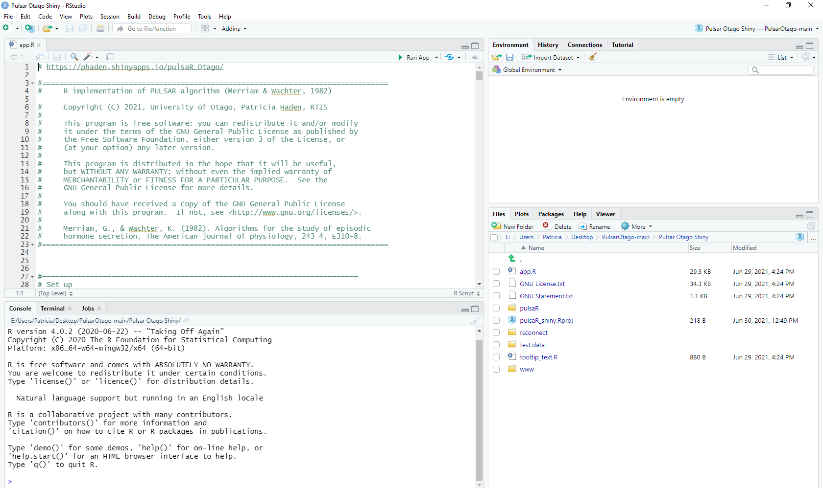

**File app.R Selected**

At the top of the upper-left pane will be a button labelled **Run App**, beside a green triangle. Click Run App to launch Pulsar Otago.